**February 2020 2020**

**ARTY FACTS**

Lower Clarence Arts and Craft Association

Ferry Park Gallery PO Box 194, MACLEAN, NSW, 2463

Email: [info@ferrypark.net](mailto:info@ferrypark.net) Website: [www.ferrypark.net](http://www.ferrypark.net)

2463

Email: [info@ferrypark.net](mailto:info@ferrypark.net) Website: [www.ferrypark.net](http://www.ferrypark.net)

**Upcoming Events**

**Annual General Meeting**

**13th March 11am at Maclean Services Club**

**Official opening of Plunge**

**Friday 27th March at 6pm at Ferry Park Gallery**

**Including:**

**. opening LCACA Annual 8x8 Exhibition**

**. InFocus Photo Competition prize presentation**

**President's Opening Remarks:**

Welcome back and I hope you all had a relaxing Christmas and New Year. Most of you will be aware that we have been in discussions with Council about the Drafting of a Plan of Management (POM) for Ferry Park and negotiation of a new lease. Thank you to those members who took the time to make a submission to Council expressing concerns about the 1st draft of the POM. The Executive are meeting with the Mayor and General Manager of Council to express our concerns about the lack of consultation undertaken by Council and need for more detail about future leasing arrangements. An amended draft will go to a Council Committee meeting on 19 February at which I will make a deputation to Councillors requesting the inclusion of provisions for a 10 to 15 year lease amongst other issues. I’ll keep you up to date on the progress.

Don’t forget the **Annual General Meeting will take place on 13 March at 11am**. Please come along. This is your opportunity to nominate for a position on the Committee. A number of positions have been vacant this past year which puts an additional burden on the few remaining committee members. We would really appreciate your help in sharing the load. Some of the positions don’t require a lot of ongoing work. All positions will be open for nominations.

The committee positions are: President, Vice President x2, Secretary, Minute Secretary, Treasurer, Assistant Treasurer, Gallery Coordinator x 2, Artyfacts Editor, Publicity and Promotions Officer, Exhibitor Representative x 2. A description of each position is available in the gallery office. Nomination forms are also available in the office with **nominations closing on 28 February**.

Bev Schofield has advised the committee that she is leaving the area and the committee has reluctantly accepted her resignation. Bev has been a valued member of the LCACA who could be relied upon to take on extra responsibilities in our annual Art and Craft Exhibitions and more recently in managing the Junior Art Section in the Gallery. Thank you Bev. If anyone is interested in taking over the management of Junior Art, Bev is happy to give a handover of information.

Ainslie

**Office Bearer**

**President**

Ainslie Langshaw

**Vice Presidents**

Penny Stuart

**Secretary**

Gloria Lee

**Treasurer**

Marlene Sheehan

**Assistant Treasurer**

Gloria Lee

**Gallery Coordinators**

Sonia Stanton & Lynne Gehrke

**Exhibitor’s Representative**

Suz Monin & Penny Stuart

**Exhibition Coordinator**

Fay Griffiths

**Minute Secretary**

Vacant

**Publicity Officer**

Vacant

**Arty Facts Editor**

Kaye Grayson

**Events Coordinator**

Vacant

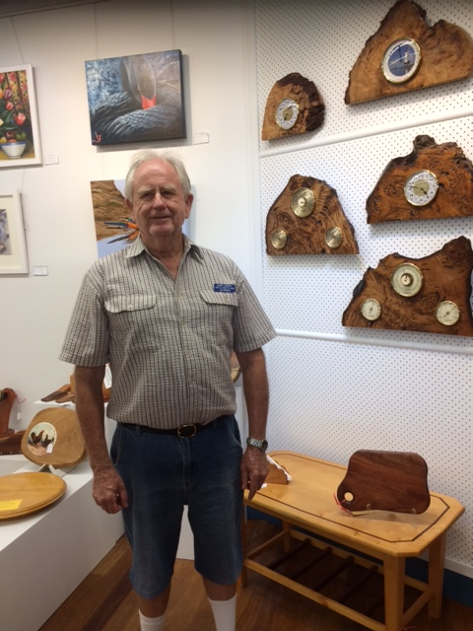

We were sad to also lose one of our life members Marie Rheinberger during the week.

Our thoughts are with her family.

An application was received for Catherine McGuire to hold Crochet classes for members on Monday mornings in the Members room.

*Happy crocheting*

*Our thoughts are with Marcia Rutledge & her family with the passing of Marcia's husband Warwick*



**Annual General Meeting**

**Our AGM will be held at Maclean Services Club on 13th March at 11am.**

**Nominations are now open. Place you nomination in the box on the sign-in desk or email** **secretary@ferrypark.net**

**All positions are declared vacant.**

**We urge you to consider nominating for a position.**

**Artist of month display for February is a selection of works from woodworker Jim Morison**

**Exhibitors’ Representatives’ Report**

After two very good trading months it is up to all exhibitors to keep the momentum through the year. One way we can do this successfully is in presentation of exhibits in the gallery. To this end we ask all exhibitors to dust, tidy up, clean (those geckos and insects are relentless) and sweep daily as well as to fill any empty spaces when goods are sold. Please call members if they do not have stock in the storeroom or paintings store. We want the gallery to look its best at all times. Artists are asked to have spare works ready to replace their stock when sold.

The 8x8 Exhibition is well on the way to another successful exhibition. If you want to enter, please pick up your entry and canvas soon as the pile is dwindling by the day. Completed canvases should be returned by 20th March.

The Opening Night is 27th March at 6pm. The big news is we have been asked to host the Opening of the CVC Plunge Festival on that night as well so it will be an important event on our calendar as well as bringing visitors from throughout the valley.

We have a request for old style tea cups (not saucers) to use on the night to serve the punch. If you can help please let Penny or Suz know.

Penny and Suz

**Gallery Co-ordinator report**

Happy New Year to all our exhibitors and members!

A big thank you goes to Suz Monin for her display as our first Artist of the Month for January 2020. February 2020 showcases Jim Morrison and his woodwork as our Artist of the Month.

I have been a co-ordinator for a full year now, and fully understand the challenges faced each month to ensure each exhibiting member has their work displayed in the gallery.

Having just completed my duty at the end of January, I feel members need to be reminded of the following points that are part of our Conditions of Contract & the Rules of Exhibition and Housekeeping at Ferry Park Gallery:

* Placement of work in the Gallery is at the discretion of the Gallery Coordinators and displayed in one place only except for paintings or special displays. Gallery Coordinators have the authority to change display if deemed necessary
* Exhibitors are required to clean their own display each month
* Exhibitors are asked to bring in work for rotation each 3 months and should ensure replacement stock is available.

So, to help maintain the high quality of the displays we have, I ask that exhibitors:

* clean their own display each month
* ensure there is work available for rotation, and
* resist the urge to change the display of artwork. This is done at the end of the month by the Gallery Coordinators. If you have sold a piece of artwork, contact a Gallery Coordinator.

I look forward to maintaining the high quality Ferry Park Gallery is renowned for.

Lynne Gehrke

**Lower Clarence Art Group Report**

by June Alexander

Art Group have been on a break and will re-commence Tuesday 18th February. New members welcome.

**Embroidery Report.**

Although it's early in the year, all groups are back stitching with great precision to hopefully finish their stunning pieces to enter in the Exhibition later in the year.

In July the Embroidery Groups will join together to have a display in the Members room. More information in next month or two.

 The general public always enters our group sessions to see what we are working on. Many are Embroiderers themselves so love to see our work & inform us of their interests. It's interesting to talk to them as they come from all around the world & we love to hear what they also do even though there are sometimes language barriers but we still make ourselves understood most of the time.

The Australasian Embroidery Convention is on at the Brisbane Convention Centre from Feb. 21-23, 2020. As a number of classes are available, they are filling up quickly, some already sold out.  Check this event out on line now if you wish to partake.

On behalf of all Embroiderers who have worked with Marcia Rutledge in many areas of our Embroidery Art,  we want you to know we all send our sincere sympathy on the recent passing of your husband Warrick. Our loving thoughts & prayers are with you & your family at this sad time.

Pam Le Couteur

***Patchwork & Quilting:***

presented by Val Wright

President M.P.Q

This year Patchwork and Quilting started with a buzz. Quilts have been started for the victims of the Nymboida fires and all money raised from our Christmas Party and future Airing of the Quilts will be donated to our local Fire Fighters.

Our workshops have started with Mary showing us how to do different ways to Quilt, it was very informative.

I would like to take this opportunity to wish one and all a very healthy, happy and productive year

*A big thank you to Bev Scofield for her work with the Junior Art display. It is with sadness we accepted her resignation. Bev and husband are moving to Melbourne to be closer to family.*

*We are looking for someone to continue her good work.*

We would like to welcome a new member Betty Van-Gemert. Betty has joined our art group on Tuesday mornings.

**Next Monthly Meeting will be held at 9.30 on 3rd April 2020**

***Embroiderers:*** *Pam LeCouteur*

Although it's early in the year, all groups are back stitching with great precision to hopefully finish their stunning pieces to enter in the Exhibition later in the year.

In July the Embroidery Groups will join together to have a display in the Members room. More information in next month or two.

 The general public always enters our group sessions to see what we are working on. Many are Embroiderers themselves so love to see our work & inform us of their interests. It's interesting to talk to them as they come from all around the world & we love to hear what they also do even though there are sometimes language barriers but we still make ourselves understood most of the time.

The Australasian Embroidery Convention is on at the Brisbane Convention Centre from Feb. 21-23, 2020. As a number of classes are available, they are filling up quickly, some already sold out.  Check this event out on line now if you wish to partake.

On behalf of all Embroiderers who have worked with Marcia Rutledge in many areas of our Embroidery Art,  we want you to know we all send our sincere sympathy on the recent passing of your husband Warrick. Our loving thoughts & prayers are with you & your family at this sad time.

Pam Le Couteur

welcome.